**ABSTRACT**

This abstract introduces JobGrids, an advanced employee recruitment system developed using Django, JavaScript, and HTML. The system incorporates three primary models: job seekers, providers, and admin. Job seekers can effortlessly search for job opportunities, while providers have the ability to post job listings. The admin role involves verifying new providers' licenses and effectively managing the entire system. JobGrids offers a user-friendly interface and robust functionality, seamlessly connecting job seekers with providers and providing efficient administrative control.

1. **Admin :**

* System Management: The admin module enables efficient management of the entire system. Admins have the authority to set user permissions, configure system settings, and monitor system activities. This allows them to maintain system integrity, handle any technical issues that arise, and ensure a seamless user experience for both job seekers and providers.
* Oversight and Compliance: The admin module ensures compliance with regulatory and organizational requirements. Admins can enforce policies, guidelines, and standards, ensuring that job postings adhere to ethical, legal, and quality standards. They also have the ability to conduct audits and address any non-compliance issues promptly.
* License Verification: The admin module ensures the authenticity of new providers by meticulously verifying their licenses. This process adds an extra layer of trust and credibility to the system, safeguarding job seekers from potential fraud and ensuring that only legitimate providers can post job listings.

**2.Job Seekers:**

The job seekers module in JobGrids provides the following key functionalities:

1. Job Search: Job seekers can easily navigate the system to search for relevant job openings. They can utilize various filters such as location, industry, experience level, and job type to refine their search and discover the most suitable job opportunities. This functionality allows job seekers to efficiently explore a wide range of options and find jobs that meet their specific requirements.
2. Application Submission: Once job seekers identify a desirable job listing, they can submit their applications through the system. The module allows job seekers to upload their resumes, cover letters, and other required documents, ensuring a streamlined and organized application process. By providing this functionality, JobGrids simplifies the job application process for job seekers, enabling them to apply for multiple positions effortlessly.
3. Application Tracking: The job seekers module also includes features that enable job seekers to track the status of their applications. They can monitor the progress of their applications, receive notifications on application updates, and view their application history. This functionality provides transparency and allows job seekers to stay informed about the progress of their job applications within the system.

The job seekers module in JobGrids offers a user-friendly and efficient platform for individuals to search for job opportunities, submit applications, and track their progress. With its intuitive interface and robust functionality, the module enhances the overall job search experience, helping job seekers find their desired positions more effectively.

Top of Form

Bottom of Form

**3. Job Providers**:

The providers module in JobGrids provides the following key functionalities:

1. Job Posting: Providers have the ability to create and post job listings within the system. They can enter comprehensive details about the job, including job title, description, requirements, and desired qualifications. This functionality ensures that job listings are accurately presented to attract suitable candidates.
2. Application Management: Once job listings are posted, providers can manage the applications received from job seekers. The module allows providers to review and evaluate applications, shortlist candidates, and communicate with them within the system. This functionality streamlines the application management process, enabling providers to efficiently track and handle candidate responses.
3. Employer Branding: JobGrids also offers features that allow providers to showcase their organization's branding and culture. Providers can include their company logo, mission statement, and other relevant information to create a compelling employer profile. This functionality helps providers establish their brand identity and attract high-quality candidates who align with their organizational values

**PROJECT REQUIREMENTS**

1. **User Registration and Login for Both Job Seekers and Job Providers (Companies):**

* Job seekers and job providers (companies) will have separate registration processes tailored to their specific requirements.
* The login functionality will allow users to securely access their accounts and access the features available to them.

**2. Registration Form for Job Seekers to Submit Their Personal and Academic Information**

**3. Feature to Add New Job Openings for Companies:**

* Companies registered on the platform will have the ability to post new job openings.
* They can provide detailed job descriptions, including job title, responsibilities, qualifications, salary range, location, and application deadlines.

**4. Feature to Approve New Company Registrations into the System by Verifying Uploaded Documents**

**5. Feature for Job Seekers to Search Jobs as per Their Requirements**

**6. Feature for Applying to Jobs:**

* Job seekers can apply to job openings directly through the system.
* They can submit their application, which may include uploading their resume other supporting documents.

**7. Feature for Companies to View Job Applications:**

* Companies will have access to a dashboard or interface where they can view and manage the job applications they receive.
* They can review applicants' details, such as their resumes, cover letters, and other submitted documents.

**8. Security and Privacy:**

* The system should implement appropriate security measures, including data encryption, to protect user information and ensure privacy.
* Access control and authorization mechanisms should be implemented to restrict access to sensitive functionalities and data.

**9. Ability to Select/Reject Candidates:**

* Companies can make decisions on selecting or rejecting candidates based on their job applications.

**. Feature for Adding Reviews About the System:**

* Users, both job seekers and job providers, will have the option to provide feedback and reviews about their experience with the system.

**FEATURES AND HIGHLIGHTS OF THE PROJECT**

The features and highlights of the JobGrids project in Python Django, which contains employee recruitment, job searching and edition, three modules (Admin, Job Seeker, Job Provider), include the following:

**1. User Registration and Authentication:**

- Users can register as admin, instructor, or student.

- User authentication and login system to access different functionalities.

**2. Admin Module:**

- Admin can manage and maintain the system.

- Admin can view and manage all user profiles.

- Admin can verify job providers by checking their license.

- Admin can view interesting insights about the system

-Admin can view trending jobs in the system

**3. Job Seeker Module:**

**-** Job Seekers can view all jobs that available in the system

- Job Seekers can filter out jobs by different category

- Job Seekers can search jobs with the job title, preffred location, and qualification.

- Job Seekers can apply for the job as per their requirement

- Job Seekers can view and edit their profile details.

- Job Seekers can Change their Password

**4. Job Provider Module:**

- Job Providers can view their profile information.

- Job Providers can add new job postings.

- Job Providers can delete their job postings.

- Job Providers can view applications of their job postings

- Job Providers can select/reject applications

- Job Providers can view and edit their profile details.

- Job Providers can Change their Password

**TECHNICAL ASPECTS**

-**Architecture of your project**

**-Class Diagram**

**Django Framework**:

Django is the primary framework used for building the LMS project. It provides a robust foundation for developing web applications, offering features such as URL routing, database connectivity, authentication, and templating.

**Python:**

The LMS project is written in Python, a versatile and powerful programming language known for its simplicity and readability. Python is used to implement the backend logic, handle data processing, and perform various system-level operations.

**HTML/CSS/JavaScript**:

The project utilizes front-end technologies such as HTML, CSS, and JavaScript to develop the user interface and enhance user interactions. These technologies are essential for creating responsive and visually appealing web pages.

**Database Management System (DBMS):**

The project utilizes a DBMS to store and manage data related to users, courses, content, assessments, and grades. Popular choices for DBMS in Django projects include PostgreSQL, MySQL, and SQLite.

**THIRD PARTY LIBRARIES**

**Django REST Framework:**

This library is used to build APIs for the LMS project, enabling seamless communication between the front-end and backend.

**jQuery:**

jQuery is a JavaScript library used to simplify DOM manipulation and handle AJAX requests within the project's front-end components.

**Bootstrap:**

Bootstrap is a popular CSS framework used for responsive web design and UI components, making it easier to create visually appealing and mobile-friendly interfaces.

**Pillow**

A powerful library for image processing and manipulation.

**CLASS DIAGRAM**

**CHALLENGES FACED DURING THE DEVELOPMENT**

**Time Slot Management:**

Developing a system for managing time slots can be complex, especially if it involves availability, booking, and conflict resolution. You need to handle concurrent access, prevent double booking, and provide a user-friendly interface for selecting available slots.

**Solution:** Use Django's form and validation features to create a user-friendly interface for selecting time slots. Implement proper locking mechanisms or database transactions to handle concurrent access and prevent double booking. Consider using a library like django-scheduler or designing your own solution based on your specific requirements.

**Profile Updation and Edition:**

Providing a user-friendly interface for updating and editing user profiles requires designing intuitive forms, handling data validation, and ensuring proper data persistence.

**Solution:** Use Django's form and model form features to create forms for profile updation and edition. Implement client-side and server-side validation to ensure data integrity. Leverage Django's form handling capabilities to bind form data to model instances and save updates to the database.

**Testing and Validation**:

Validating the functionality and ensuring the robustness of the project requires comprehensive testing at different stages of development. It's important to cover edge cases, handle input validation, and perform integration testing.

**Solution:** Write unit tests and integration tests using Django's testing framework. Create test cases that cover different scenarios, including edge cases and invalid inputs. Use tools like Selenium for browser automation to simulate user interactions and test the application's functionality end-to-end.

**Data Modeling:**

Designing an efficient database schema to handle user profiles, time slots, and instructor information can be challenging. You need to carefully plan the relationships between different entities and ensure proper indexing and querying for efficient data retrieval.

**Solution**: Spend time on data modeling before starting development. Identify the entities, relationships, and attributes needed for the project. Use Django to define models and establish relationships between them. Consider the performance implications of your design choices.

**Location-Based Search:**

Implementing a search feature to find instructors near a particular locality involves integrating with geolocation services and querying the database based on proximity. This requires handling geospatial data and performing efficient spatial queries.

**Solution**: Utilize Django's support for geospatial data by using the GeoDjango extension. Store instructor locations as spatial fields and use Django's spatial query capabilities or spatial libraries like PostGIS to perform proximity searches. Integrate with external geocoding services like Google Maps or OpenStreetMap to convert user addresses into coordinates for searching.

**IMPORTANT SCREENSHOTS WITH EXPLANATION**

**HOME PAGE:**



**STUDENT HOME PAGE:**

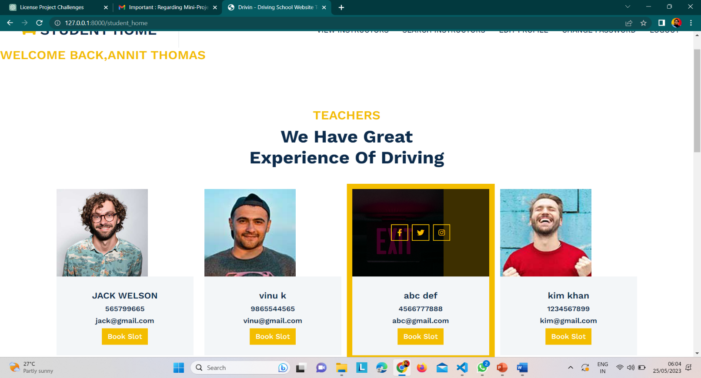

**STUDENT SLOT BOOKING PAGE:**

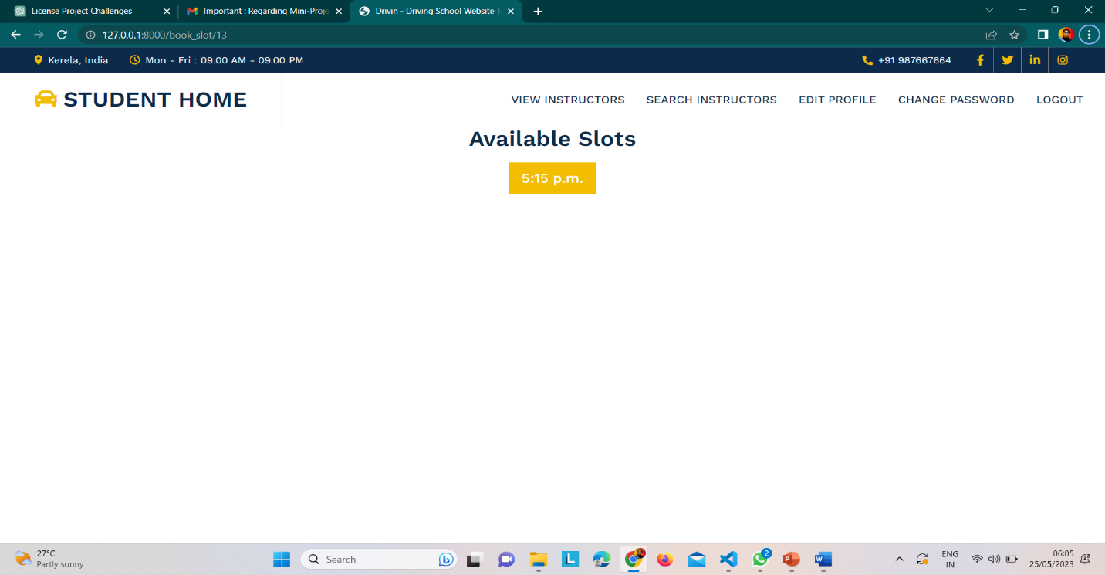

To create a student slot booking page, you'll need to design a web interface that allows students to view available slots and book appointments with instructors.

**STUDENT PROFILE EDTING**

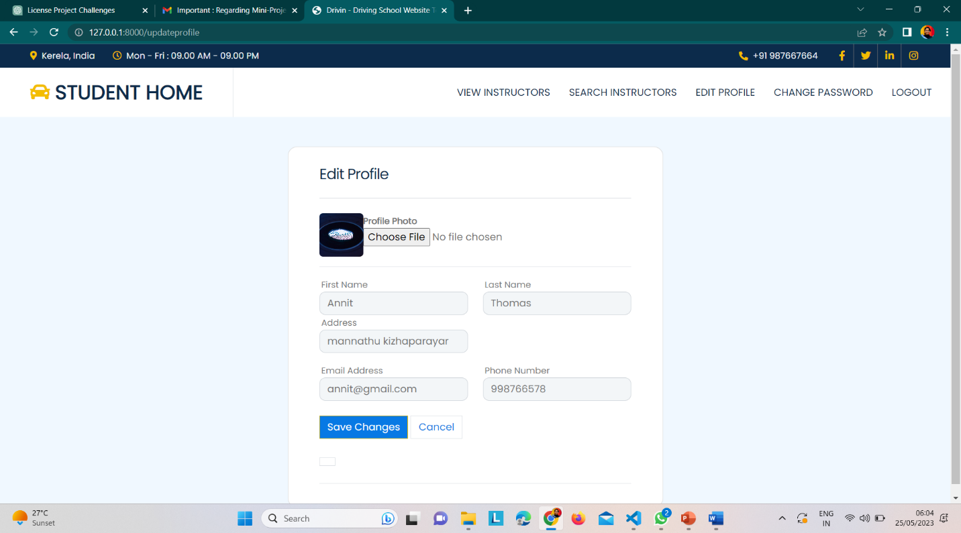

To create a student profile editing feature, you need to provide students with a web interface where they can update their profile information.

**SEARHING INSTRUCTOR BY USING LOCATION:**

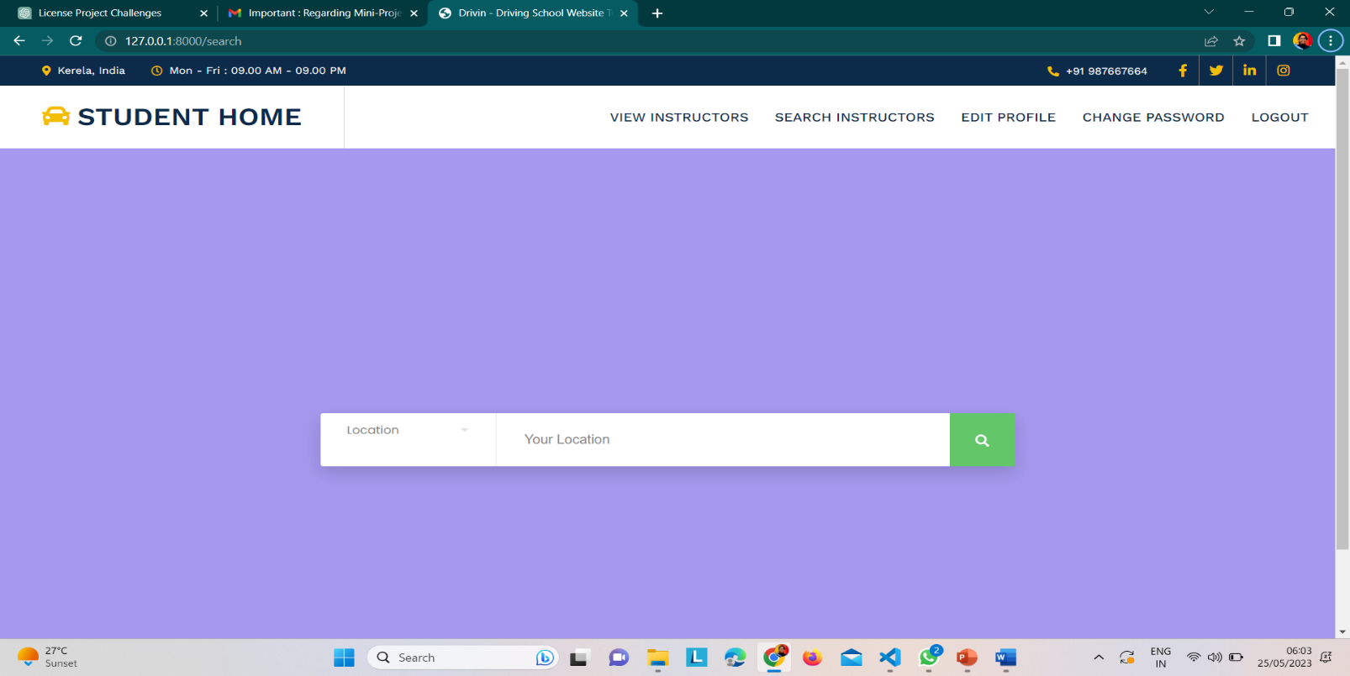

To enable searching for instructors based on location, you can implement a feature that allows students to find instructors within their desired locality.

**CHANING PASSWORD OF STUDENT:**

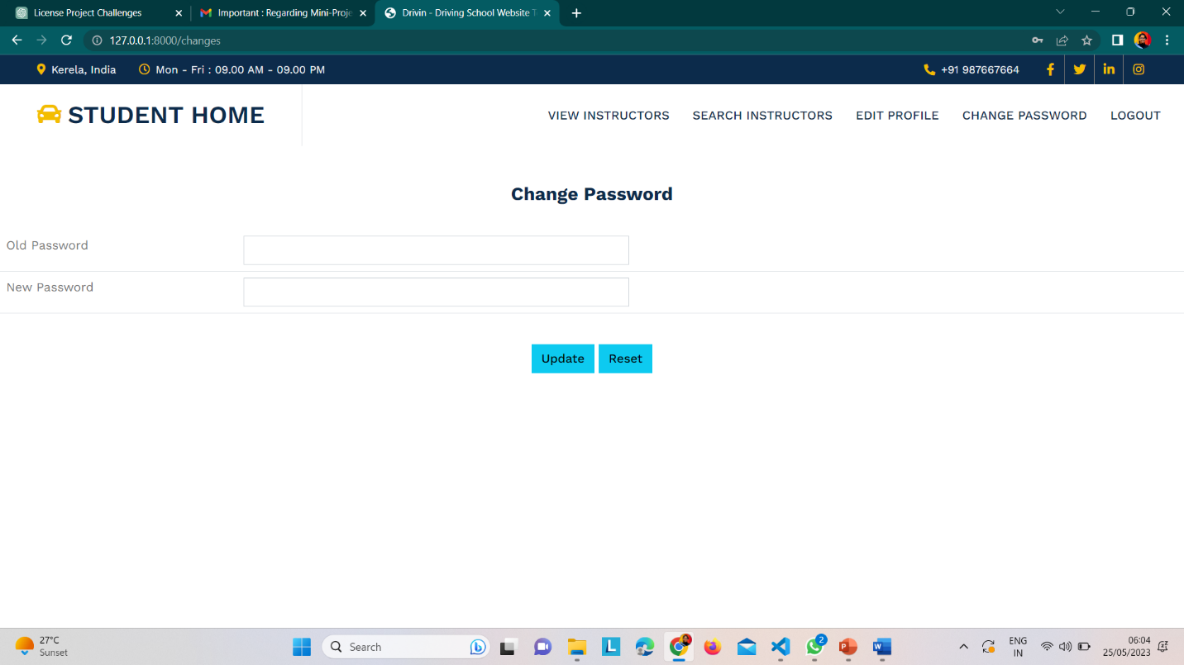

**FUTURE ENHANCEMENTS**

There are several future enhancements you can consider for your driving license project in Python Django. Here are some suggestions:

1. **Online Payments:**

Integrate a payment gateway to allow users to make online payments for services like license fees, booking time slots, or instructor fees. Implement secure payment processing and provide users with a seamless and convenient payment experience.

1. **Notification System:**

Implement a notification system to keep users informed about important updates, such as appointment confirmations, changes in time slots, or document verification status. Use Django's built-in messaging framework or integrate with email or SMS services to send notifications to users.

1. **Mobile Application:**

Develop a mobile application companion for your project to provide users with a mobile-friendly interface and enhanced accessibility. The app can include features like profile management, time slot booking, instructor search, and push notifications.

1. **Rating and Feedback:**

Allow users to rate and provide feedback on their learning experience with instructors. Implement a rating system and a feedback mechanism to collect user reviews. Display average ratings and reviews to help other users make informed decisions when selecting instructors.

1. **Automated Scheduling:**

Implement an automated scheduling system that suggests available time slots for users based on their preferences, instructor availability, and the user's previous booking history. This can help optimize scheduling and reduce the manual effort required for managing time slots.

1. **Analytics and Reporting:**

Incorporate analytics and reporting features to track key metrics and generate insights about user activities, popular time slots, instructor availability, and overall system performance. Use data visualization tools to present the information in a visually appealing and understandable manner.

1. **Multilingual Support:**

Add support for multiple languages to cater to a wider user base. Allow users to select their preferred language and provide translations for the user interface, instructional content, and communication messages.

1. **Integration with Licensing Authorities:**

Explore possibilities for integration with licensing authorities' systems to streamline processes such as license verification, document verification, and application status tracking. This can help automate administrative tasks and enhance the efficiency of the licensing process.

1. **Gamification Elements:**

Incorporate gamification elements into the application to make the learning process more engaging and rewarding. For example, you can introduce achievement badges, progress tracking, or leaderboards to motivate users and make the learning experience enjoyable.

Consider prioritizing these enhancements based on your users' needs, market demand, and available resources. Regularly gather user feedback and conduct usability testing to identify areas for improvement and guide your future enhancements.

**CONCLUSION**

In conclusion, the driving license project developed in Python Django encompasses various essential features such as time slot management, profile updation and edition, and searching for instructors near the locality. By overcoming the challenges associated with data modeling, authentication, time slot management, location-based search, and profile management, the project provides a robust and user-friendly platform for obtaining a driving license.

The project offers a solid foundation for future enhancements and improvements. Some potential areas for further development include integrating online payment functionality for seamless transactions, implementing a document upload feature for required license application documents, and incorporating a notification system to keep users informed about important updates.

Additionally, developing a mobile application companion can enhance accessibility and convenience for users on-the-go. Other valuable enhancements include implementing a rating and feedback system, automating scheduling processes, incorporating analytics and reporting features, adding multilingual support, exploring integration with licensing authorities' systems, and introducing gamification elements to make the learning experience more engaging.

By prioritizing these enhancements based on user needs, market demand, and available resources, the driving license project can evolve into a comprehensive and feature-rich solution. Regular user feedback and usability testing will be instrumental in driving the project's continuous improvement and ensuring a high-quality user experience.

Overall, the driving license project in Python Django provides a solid foundation for obtaining a driving license, and with the suggested future enhancements, it has the potential to become a comprehensive and user-centric solution for individuals seeking to acquire or renew their driving licenses.